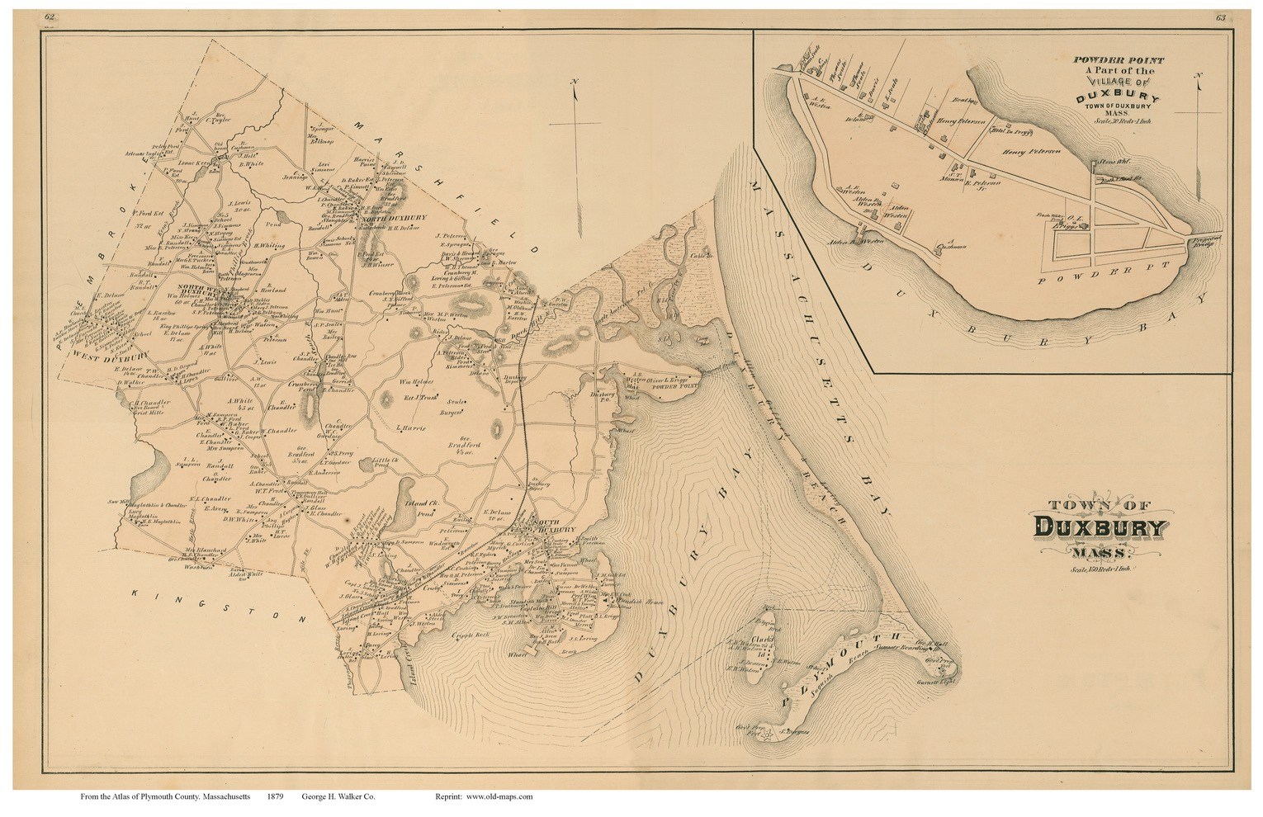
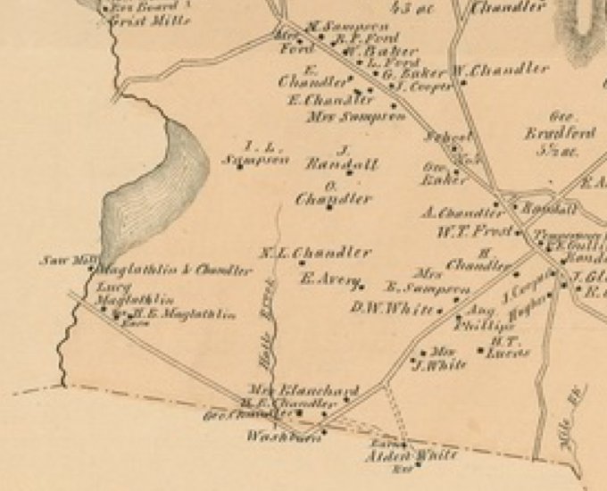
From Plymouth County 1879 published by Geo. H. Walker & Co. ,1879 . With 2nd map showing Historic O’Neil Farm location - E. Avery - enlarged.

On July 10, 1866 Carl O’Neil’s great-great grandfather Ebenezer Avery of Plymouth, MA purchased through a public auction “the [Duxbury] homestead farm of the late Nathan Chandler deceased containing about fifteen acres of pasture and mowing land with all the buildings there on standing... Also about four acres of what is called the Brook Pasture...”. Plymouth County Deed B335.

The acreage and buildings were part of the “late Ira Chandler” estate purchased by Nathan Chandler on January 16, 1855. Plymouth County Deed B263 This farm containing the farmhouse, barn, and pasture is now at the heart of the Historic O’Neil farm.

At the time he purchased land in Duxbury, Ebenezer and his family had only been living in Massachusetts for around 6 months. They had recently moved from Vermont where Ebenezer had worked for 30 years at the Vermont State Journal in Montpelier, VT. Ebenezer was a trained printer initially publishing the Vermont Advocate in Chelsea, VT. In the 1830s he merged the Vermont Advocate’s subscriber list with the Vermont State Journal.

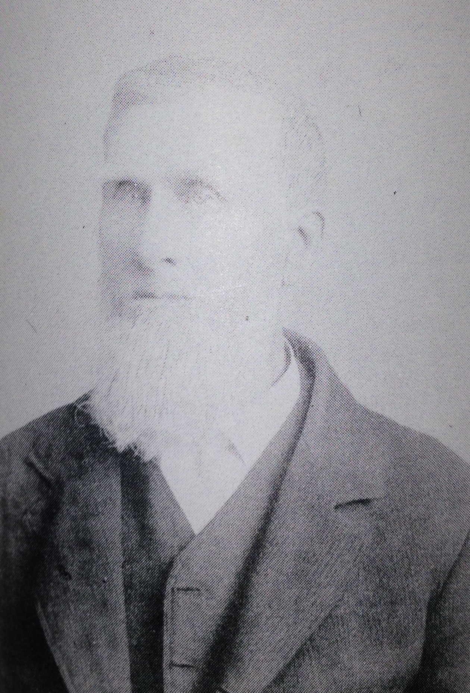
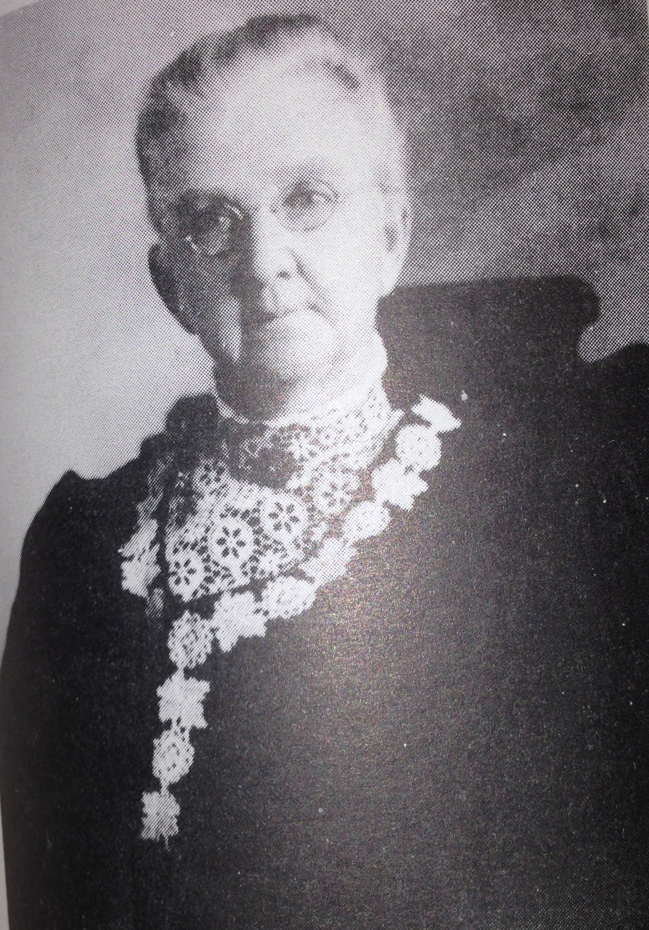
Originally from Plainfield, NH, Ebenezer Avery was born in 1808. At the age of 24 he married another Plainfield native, Rosamond Spaulding. They had five children while in Berlin, VT, only two of whom lived to move with them to Massachusetts: son Winslow Wright Avery (1836- 1908) born in 1836 and Carl O’Neil’s great-grandmother Rosamond Spaulding Avery (1840-1913) born in 1840. In addition to his newspaper career, Ebenezer spent time farming on his homestead in Berlin, VT where he spent “the greater part of the labor of which he accomplished before and after his day's work in the office. ... His ambition and energy in this respect were remarkable.” Plymouth Old Colony Newspaper Nov. 1881 - Ebenezer’s Obituary. Images from "Ancestral Lines of Herbert Spaulding Avery 1883 - 1968" by Tom Avery Benson
Ebenezer Avery(1808-1881)
Rosamond Spaulding
(1808-1891)

Upon arriving in Massachusetts, Ebenezer continued his involvement with the newspaper business and together with his son Winslow Avery, who was also trained as a printer, purchased The Old Colony Sentinel. This paper was published until 1872 when Winslow Avery consolidated it with the Plymouth Old Colony Memorial forming a partnership with C. C. Doten. Together they owned Old Colony Memorial through the 1880s.

Between 1866 and 1881 Ebenezer Avery expanded his farm and aquired the abutting Duxbury land from Gershom Bradford, Martin S. Chandler, Henry B Maglathlin, Amasa Chandler, and John Cooper and ultimately owned about 63 acres (*see note). One of Ebenezer Avery’s ambitions for his farm was maple sugaring. From Vermont, he brought maple saplings which were duly planted on his Duxbury homestead farm. Apparently overeager for the results he tapped the trees too young and many of them died. However, some of these trees still remain by the O’Neil home.

In 1874 Ebenezer’s daughter Rosamond Avery (1840-1913) married Horatio Chandler (1835 - 1917) son of Nathaniel Lewis Chandler and Sally W. Sampson. The Nathaniel L. Chandler family owned the neighboring farm - a portion of which became part of the Historic O’Neil Farm. During Ebenezer and Rosamond Avery’s life on the farm Rosamond and Horatio’s children Rosa Chandler (1875 - 1963) and Mabel Chandler (1877 - 1966) were born.

Ebenezer Avery passed away on his Duxbury farm on November 16, 1881.
One obituary reported he was a “Journalistic writer of ability as well as a ready speaker and debater”. Another wrote, “Everywhere he was respected and enjoyed the rare reputation of being a thoroughly honest concientious man.”

The year after his father’s death, Winslow Avery sold his undivided half-portion of the Duxbury farm to his sister Rosamond.

On April 17, 1891 Ebenezer’s wife Rosamond (Spaulding) Avery passed away leaving the majority of her estate to her daughter Rosamond Chandler. Rosamond (senior) was living with her daughter, son-in-law (Horatio Chandler), and grandchildren Rosa and Mabel on the [Historic O’Neil] farm. In 1900, Rosa married Edward Samuel O’Neil (1873 - 1956) and nine years later their son, Horatio Chandler O’Neil (1909 - 1979) was born. Horatio O’Neil’s son Carl continues to live and farm on the Duxbury land that Carl’s great great grandfather Ebenezer Avery purchased back in 1866.

The O’Neil Farm connects with the Avery Farms in Plymouth.

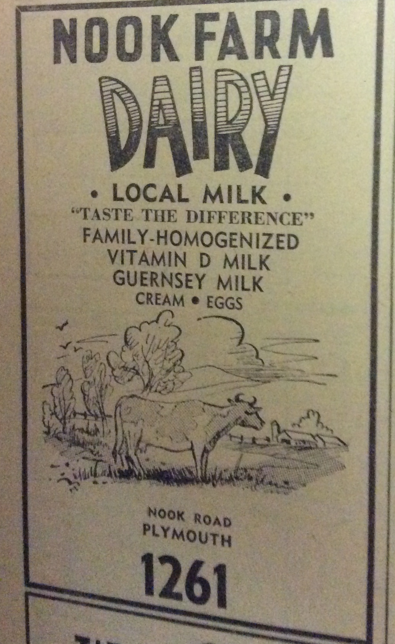
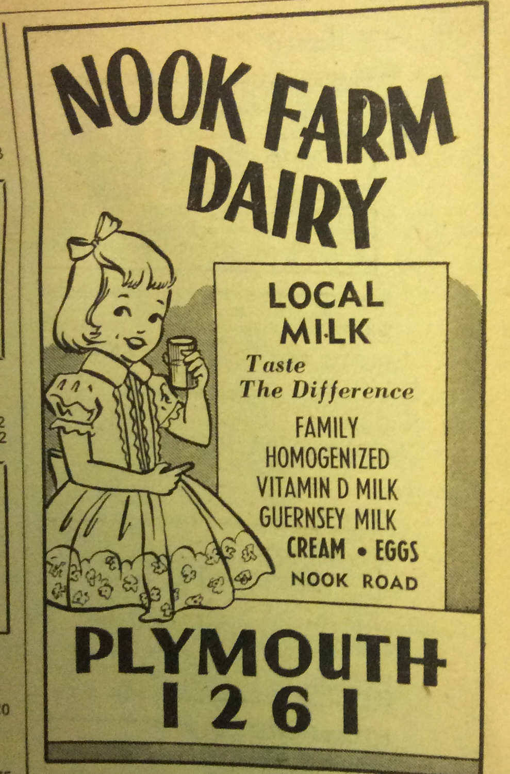
Winslow Avery’s grandson Lester E. Avery (son of Elmer E. Avery) ran the Nook Farm Dairy in Plymouth until his death 1933. The Winslow Avery family descendants owned Avery Farms where the dairy cattle were kept and Nook Farm Dairy where the milk was processed and bottled. In the 1940s Carl O'Neil, along with his brother Edward and sister Barbara, obtained Guernsey calves from the Avery Farms. These Guernseys became part of the O’Neil milking herd. Also, Carl O’Neil remembers taking milk from the O’Neil cows to the Nook Farm Dairy to be processed and bottled.
Plymouth City Directories 1951 - 1960
Plymouth City Directories 1945 - 1950

Winslow Avery’s grandson Alfred owned the Plymouth farms until his death in 1956. A number of acres of this land were donated to the town.

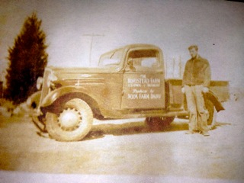
”Carl’s father Horatio Chandler O’Neil (1909 - 1979) and the milk truck”
from Family Pictures 1930s
Horatio had been working with Carl’s grandfather Edward Samuel O’Neil in the dairy business. The truck’s door panel says:
THE
HOMESTEAD FARM E.S. O’Neil - unreadable
Producer for
NOOK FARM DAIRY

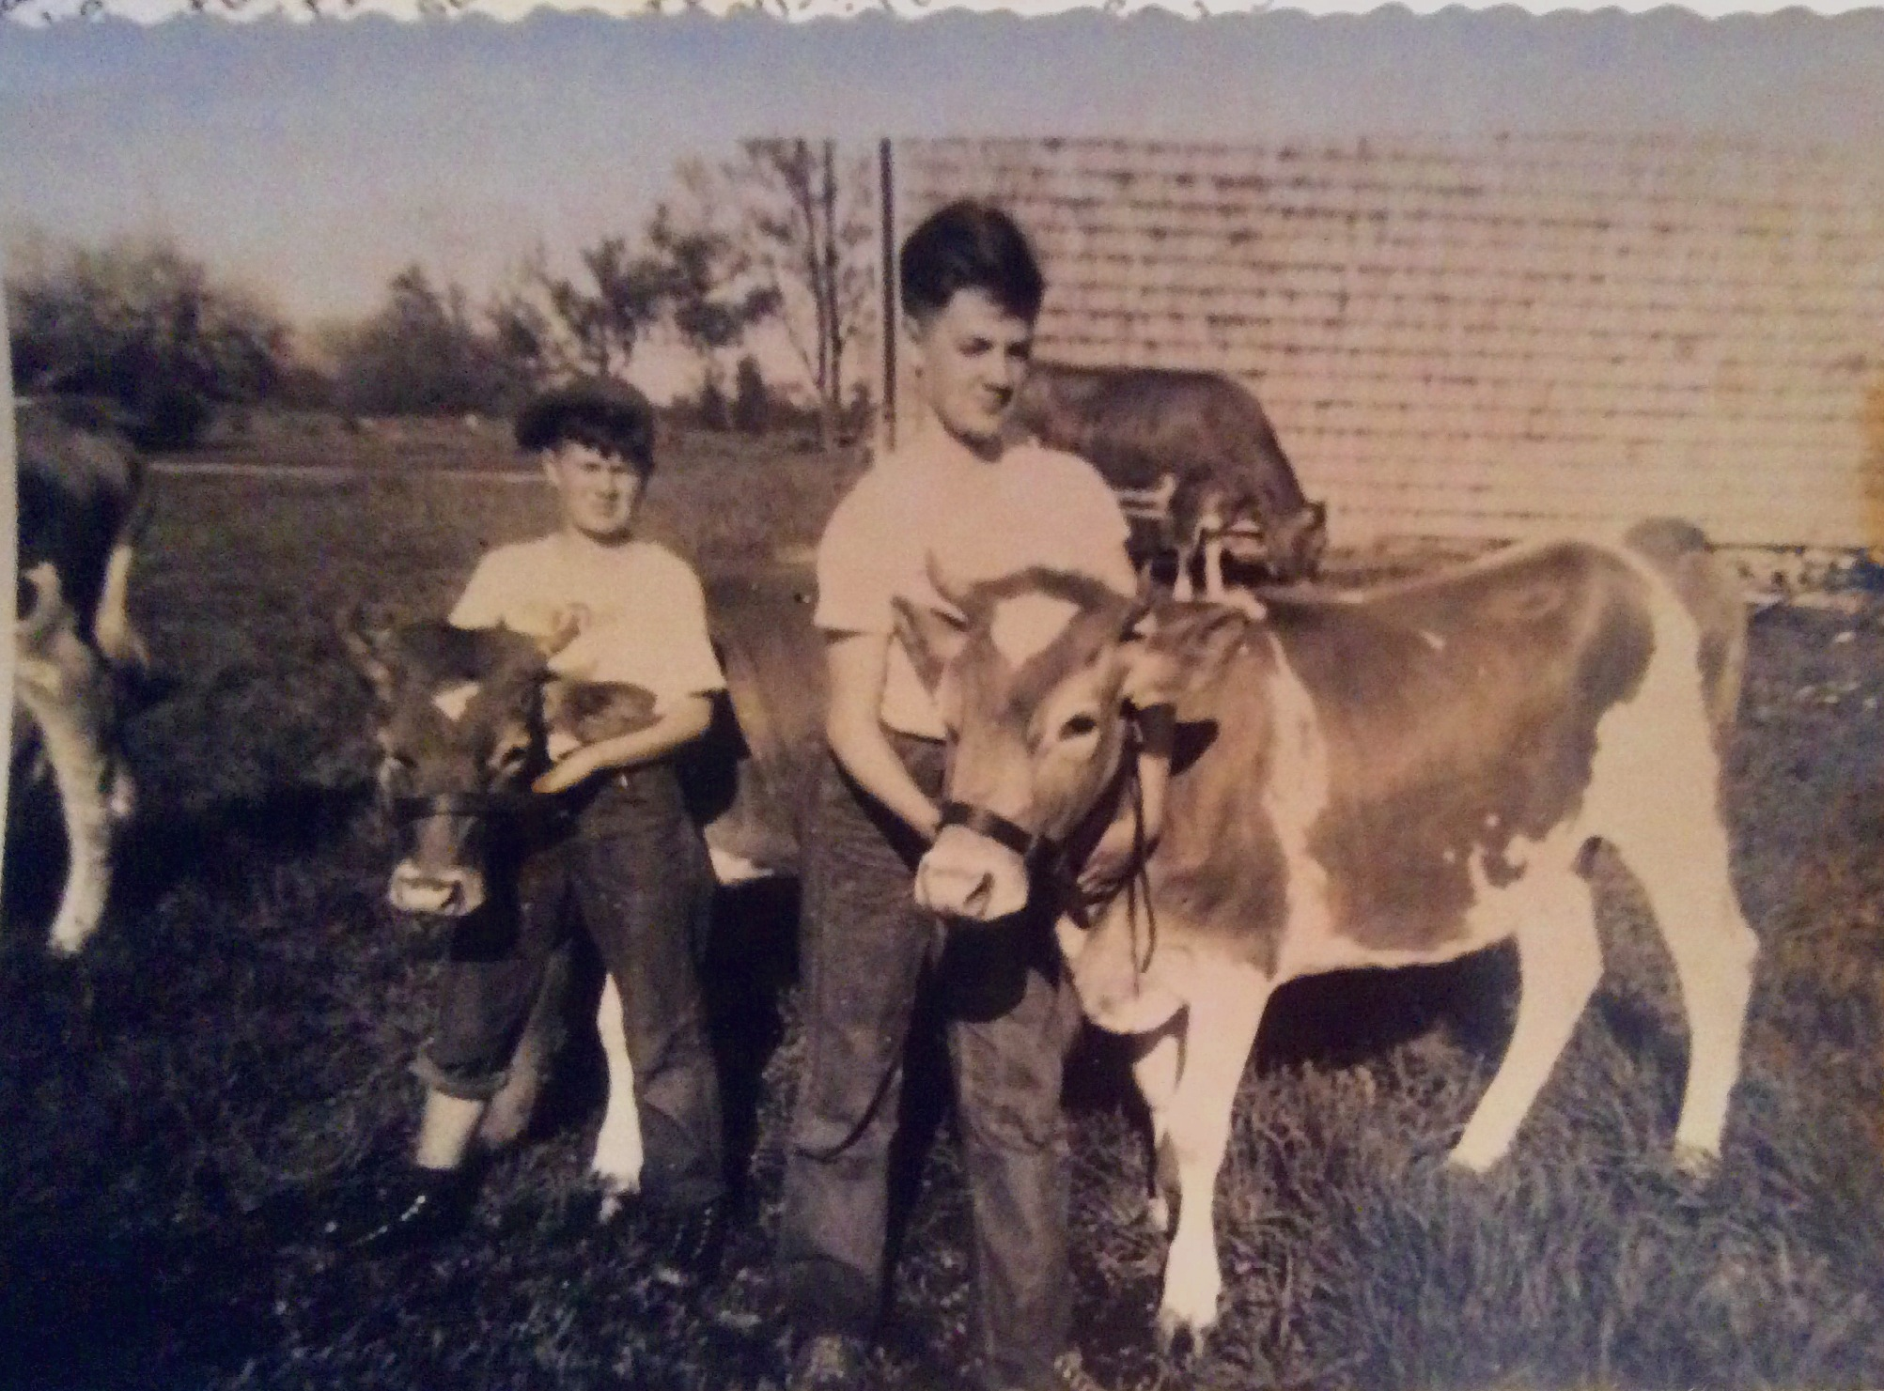
“The O’Neil children’s Guernseys from Avery Farms, Plymouth, MA”
from Family Pictures 1947
Pictured: Carl with yearling “Avery Farm Prudence”, Edward with yearling “Avery Farm Buttercup, in background is Barbara’s cow “Avery Farm Dawn”. These cows were Carl, Barbara, & Edward’s first calves to show at the local fairs. All were registered with the American Guernsey Cattle Club.

Sources:
Winslow Avery Biography: One of a thousand a series of biographical sketches of one thousand representative men resident in the Commonwealth of Massachusetts, A.D. 1888-'89
compiled under the editorial supervision of John C. Rand. Published 1890 by First National Pub. Co. in Boston .

Genealogical record of the Dedham branch of the Avery family in America by Jane G.(Avery) Carter Published 1893 by Winslow Avery, Plymouth, MA Press of Avery & Doten.

*note: In 1891 Rosamond (Avery) Chandler inherited the Avery farm from her mother Rosamond Spaulding Avery - Plymouth County Probated Will Recorded Vol. 190 Page 392. On the 1913 Duxbury Assessor’s Map Rosamond owns about 63 acres located around the homestead off Winter St..

Maple Trees, Guernseys from Avery Farms, Milk to Nook Farms - Carl and Barbara.

Horatio Chandler: Biographical Review vol. XVIII, Containing Life Sketches of Leading Citizens of Plymouth County, MA 1897 Boston Biographical Review Publishing Company.

Mabel and Rosa Chandler birth records - Births Registered in the Town of Duxbury for the year 1877 ; includes 1875 and 1876 births.

Old Colony Newspaper Nov. 19, 1881

